UNIVERSITY OF WAH (UOW)

DEPARTMENT OF COMPUTER SCIENCE



BSCS 3RD B

REG #: UW-24-CS-BS-088

SUBMITTED BY: SAADI SAFDAR

SUBMITTED TO: Ms. MUNNIBA KHAN

COURSE TITLE: DATA STRUCTURES

COURSE CODE: CS – 201 L

LAB REPORT # 7

Assigned task in lab.

// Create a list of atleast 5 nodes
// data values should be 15, 13, 20, 24, 2
// Insert at 2nd position: 45
// Insert at beginning: 5
// Insert at end: 37 through tail pointers

#include <iostream>
using namespace std;

struct Node {
int data;
Node* next;
Node* prev;
};

Node* head = NULL;

void insertBeginning(int value)
{
Node* newNode = new Node();
newNode->data = value;

newNode->prev = NULL;
newNode->next = head;

if (head != NULL)
{
head->prev = newNode;
}

head = newNode;

cout << "Inserted at beginning: " << value << endl;
}

void insertEnd(int value)
{
Node* newNode = new Node();
newNode->data = value;
newNode->next = NULL;

if (head == NULL)
{
newNode->prev = NULL;
head = newNode;
cout << "Inserted at end: " << value << endl;
return;
}

Node* temp = head;
while (temp->next != NULL)
{
temp = temp->next;
}

temp->next = newNode;
newNode->prev = temp;

cout << "Inserted at end: " << value << endl;
}

void insertAtPosition(int value, int pos)
{
if (pos < 1)
{
cout << "Position should be >= 1\n";
return;
}

if (pos == 1)
{
insertBeginning(value);
return;
}

Node* newNode = new Node();
newNode->data = value;

Node* temp = head;
for (int i = 1; i < pos - 1; i++)
{
if (temp == NULL)
{
cout << "Position out of range\n";
return;
}
temp = temp->next;
}

if (temp == NULL)
{
cout << "Position out of range\n";
return;
}

newNode->next = temp->next;
newNode->prev = temp;

if (temp->next != NULL)
{
temp->next->prev = newNode;
}

temp->next = newNode;

cout << "Inserted " << value << " at position " << pos << endl;
}

void displayList()
{
Node* temp = head;
cout << "Doubly Linked List: ";
while (temp != NULL)
{
cout << temp->data << " <-> ";
temp = temp->next;
}
cout << "NULL\n";
}

int main()
{
insertEnd(15);
insertEnd(13);
insertEnd(20);
insertEnd(24);
insertEnd(2);

insertAtPosition(45, 2);
insertBeginning(5);
insertEnd(37);

displayList();

return 0;
}

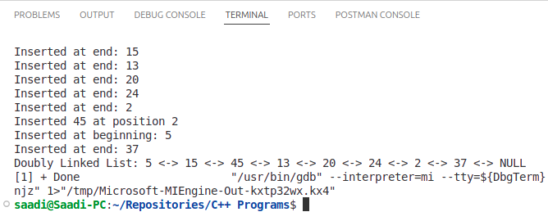
Task
#include <iostream>
using namespace std;

struct Node {
int data;
Node* next;
Node* prev;
};

Node* head = NULL;
Node* tail = NULL;

void insertEnd(int value) {
Node* newNode = new Node();
newNode->data = value;
newNode->next = NULL;

if (head == NULL) {
newNode->prev = NULL;
head = newNode;
tail = newNode;
return;
}

tail->next = newNode;
newNode->prev = tail;
tail = newNode;
}

void insertAfterPosition(int value, int pos) {
Node* temp = head;
for (int i = 1; i < pos; i++) {
temp = temp->next;
}

Node* newNode = new Node();
newNode->data = value;
newNode->next = temp->next;
newNode->prev = temp;
if (temp->next != NULL) {
temp->next->prev = newNode;
} else {
tail = newNode;
}
temp->next = newNode;
}

int searchValue(int value) {
Node* temp = head;
int position = 1;
while (temp != NULL) {
if (temp->data == value) {
return position;
}
temp = temp->next;
position++;
}
return -1;
}

int countNodes() {
Node* temp = head;
int count = 0;
while (temp != NULL) {
count++;
temp = temp->next;
}
return count;
}

void displayList() {
Node* temp = head;
cout << "Doubly Linked List: ";
while (temp != NULL) {
cout << temp->data << " <-> ";
temp = temp->next;
}
cout << "NULL" << endl;
}

int main() {
insertEnd(10);
insertEnd(20);
insertEnd(30);
insertEnd(40);
insertEnd(50);
cout << "Initial list:" << endl;
displayList();
cout << "\nInserting 25 after 3rd position:" << endl;
insertAfterPosition(25, 3);
displayList();
int searchVal = 30;
int pos = searchValue(searchVal);
if (pos != -1) {
cout << "Value " << searchVal << " found at position: " << pos << endl;
}
int totalNodes = countNodes();
cout << "Total number of nodes in the list: " << totalNodes << endl;
cout << "Inserting 60 at the end using tail pointer:" << endl;
insertEnd(60);
displayList();
totalNodes = countNodes();
cout << "\nFinal total nodes: " << totalNodes << endl;
return 0;
}

